Output:

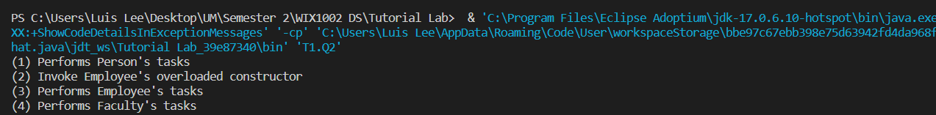

Since class Faculty extends Employee which turned out to be extends from Person class. From that, the called statement in order is “Person” constructor first, followed by “Employee” constructor then finally followed by “Faculty” constructor. From the order, we can expect that the output printed in (1)…, (2)…, (3),… (4) with the first constructor “Person” called followed by the constructor afterward.

Answer: a

4.

No, cant create an instance of Vehicle because the class itself is an abstract class. Abstract class is meant to be extended and their abstract methods are meant to be implemented by their subclasses.